RDBMS assignment component _2

Lothar Laishram pgdm hybrid sem 2

Data Exploration with SELECT command as much as possible in different aspects.

Company management data created in postgres

**1. Introduction to the Database**

*In this lab assignment, I have created a Company Management System using PostgreSQL. The system is designed to manage departments, employees, projects, and salary structures efficiently. The objective is to demonstrate practical knowledge of database design, normalization, and SQL data exploration.*

**2. Database Design Principles Applied**

* **Entity Identification**: Identified core entities – Employees, Departments, Projects, and Salaries.
* **Normalization**: Applied up to 3rd Normal Form (3NF):
  + No repeating groups (1NF)
  + All non-key attributes depend on the primary key (2NF)
  + No transitive dependencies (3NF)
* **Referential Integrity**: Maintained through foreign keys (e.g., department_id in employees table).
* **Schema Design**: Each table has a clear and specific purpose, with properly assigned data types and constraints.

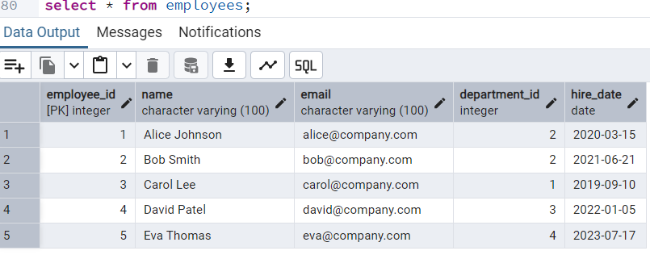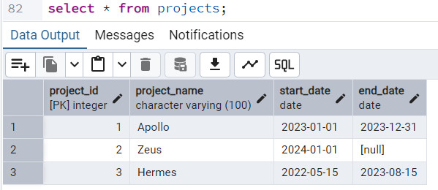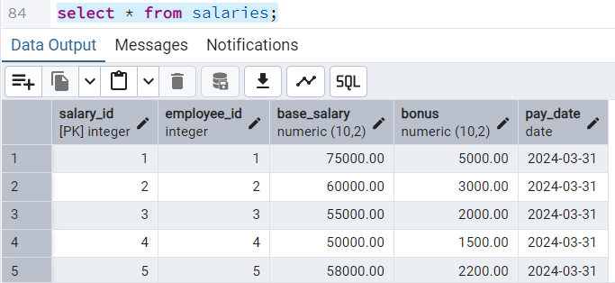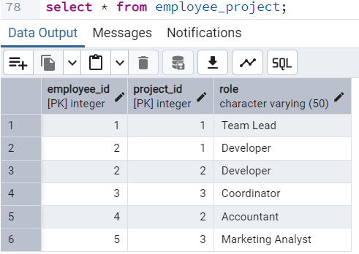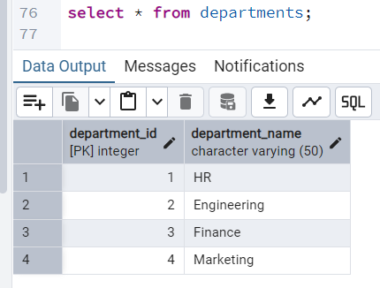

Sample database created

SELECT statements 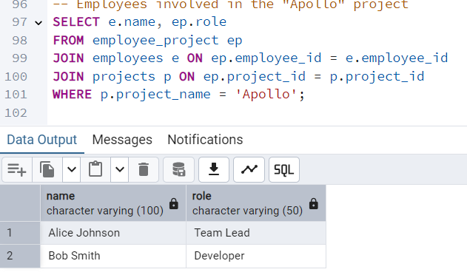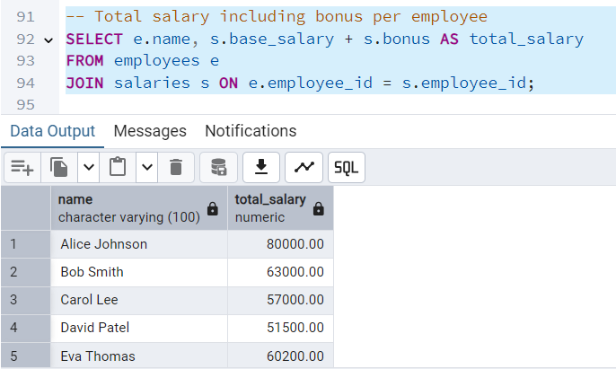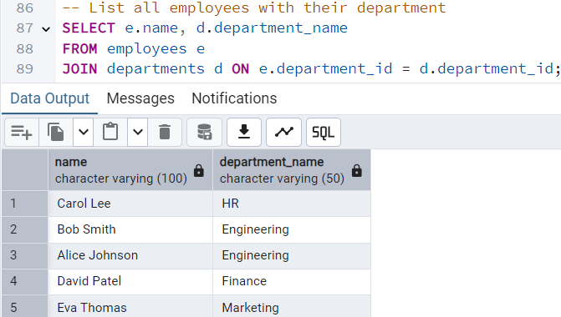

Department wise employee count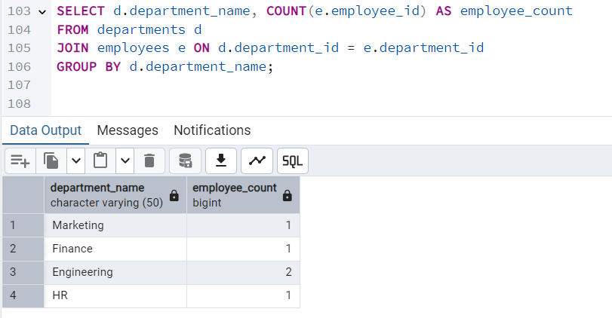

Employees working on 1 particular project

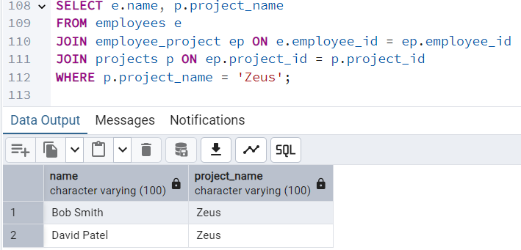

Employees and their respective departments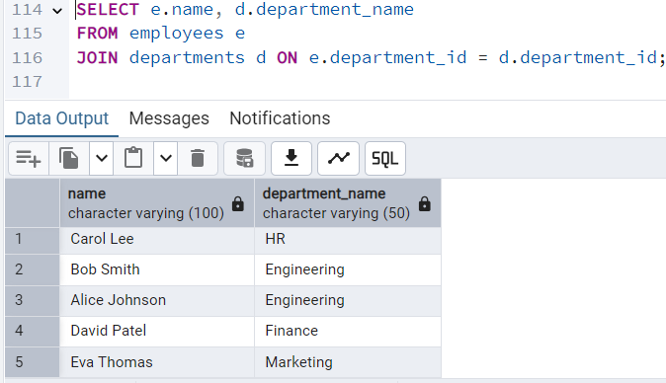

Basic select statements done.